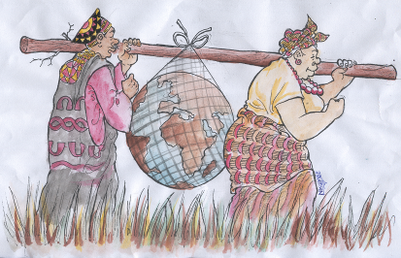
CAMEROON GENDER AND ENVIRONMENT WATCH
(CAMGEW)
Authorisation Nº.000998/RDA/J06/BAPP
Tel: (237) 675184310/697037417
www.camgew.com
Email: camgew@yahoo.com; camgew@gmail.com; P.O. Box 17 Oku, North West Region, Cameroon

Application form to be a CAMGEW Volunteer/Intern
Personal Information
- Your name.....................................................................................................................................................................
- Your age ................................. Your sex.......................... Marital status...........................................................
- Your profession...........................................................................................................................................................
- Your nationality..........................................................................................................................................................
- Your level of education ..........................................................................................................................................

Volunteer/Internship information
- Position applied...........................................................................................................................................................
- Reason for applying...................................................................................................................................................
- Duration of stay...........................................................................................................................................................
- Start date................................. End date .......................................................................................................
- Detailed proposed activities to be carried out
................................................................................................................................................................................................................................................................. ............................................................................................................................

Please note
Accommodation is 70 Euros per month
Feeding is 250 Euros (Locally available food is guaranteed)

Your security is guaranteed being with us.
Our community is rural, receptive, quiet, touristic with many local carvers, mountainous forest, various types of honey producers, many traditional dances, cultural displays, museums, lake, bird diversity, local paper industry, animal and plant diversity, etc

